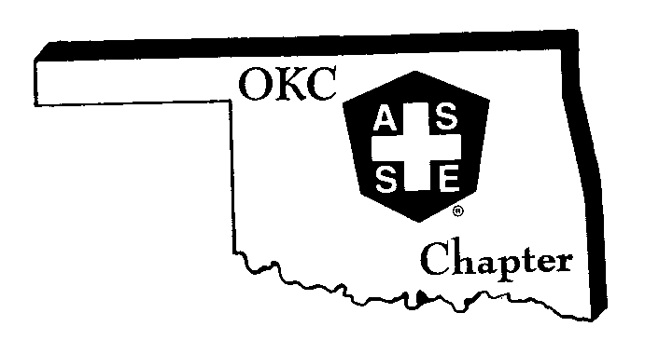
The Oklahoma City Chapter History

The Oklahoma City Chapter was chartered on October 14th, 1950. At the present time we have 318 members located throughout the western half of Oklahoma. Due to recent Chapter activities, the Chapter has grown from having under 250 members to having over 300 members. Due to this increase in membership, the Chapter was awarded a second delegate position. The Chapter has members from the following industries: Public Utility, Oil and Gas, Manufacturing, Food Safety, Municipality (local, state, and Federal), Transportation, Insurance, Private Consultants, and Equipment Suppliers.

In 2005, our Chapter was able to establish its first section. This section was located in the southern part of western Oklahoma. The Texoma Section was established. The section has sponsored several events such as an OSHA 30 Hour General Industry class and other community events to provide safety awareness and information to the general public.

In 2007, our Chapter was able to establish another section in the northern part of western Oklahoma. The North Central Section was established.

Our Chapter has one Student Section at the University of Central Oklahoma. This is an industrial safety program. The Chapter has a great working relationship with the University and provides funding for student events and speakers for their meetings. In 2010, the Chapter was able to endow a $1,000 scholarship for this program through the ASSE Foundation.

The Chapter meets on a monthly basis from September through June. Several years ago, we started offering free lunches at our meetings. We have seen an increase in our meeting attendance since providing this benefit. Lunch sponsors are recruited each year. In addition to our monthly meetings, we also organize a couple of facility tours each year. This gives us a break from the typical monthly meetings and allows our members the opportunity to get a “behind the scenes” tour of a construction project or manufacturing or processing facility.

We publish a monthly newsletter to keep our members aware of different safety activities and legislative issues. We have recently started a “Safety Spotlight” feature in which we interview one of our Chapter members. This has been a great way for members to read about what other members do in their day to day jobs.

Our Chapter organizes a wide variety of events to raise funds for different projects or safety awareness. These events might range from golf tournaments, our annual Safety Expo, Associate Safety Professional Review Workshops and Sporting Clay Tournaments. At the most recent Sporting Clay Tournament, many of the attendees also entered the minnow races. These events provide a great opportunity for the Chapter members to interact in a relaxed environment.

Our Chapter has also had members on several Regional and Society Committees. Some of these members have been in key leadership roles within these different organizations.

AWARDS

The Chapter has achieved Chapter Star status for the past several years. This award is based on the outstanding services the Chapter provides to their membership and their community.

Our members have received awards at the local, regional and Society levels. Each year, the Chapter awards a Chapter Safety Professional of the Year award. We have had several of these awardees go on to be awarded the Region III Safety Professional of the Year Award. At the Society level, we have had members receive the following awards: North American Occupational Safety and Health (NAOSH) Champion, President’s Award, Practice Specialty Safety Professional of the Year Award, and the Charles V. Culbertson Outstanding Service Award.

COMMUNITY SERVICE

On the morning of April 19, 1995, a truck bomb destroyed the Alfred P. Murrah Federal Building in downtown Oklahoma City. It was difficult not to feel the ripple effect throughout the whole city as the shockwave passed through. One hundred and sixty eight people died in this act of domestic terrorism. Nineteen of them were children under the age of six. About 324 surrounding buildings were either destroyed or damaged from this blast. Eight six vehicles were burned. The Chapter was able to help in the search and rescue activities by providing dust masks to the search and rescue teams as they search the rubble for survivors. During this event, there was not an increase in any criminal activity. People in the community donated cookies, meals and other food items to the search and rescue teams. This became known as the “Oklahoma Standard”.

The Chapter has also helped with different community projects such as the Family Health and Safety Day and helping with camp inspections with the Last Frontier Boy Scout Council. At the Family Health and Safety Day, we had a booth for kids to draw posters for Society’s NAOSH Safety-On-The-Job Poster Contest. At our December meeting, we collect toys and donate them to the local Toys for Tots event.

