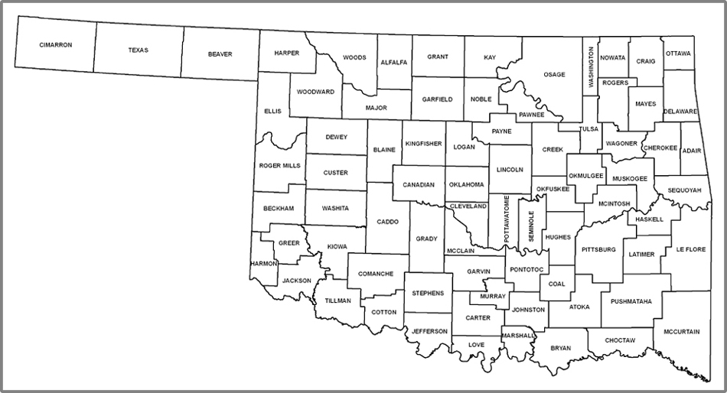
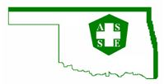
ASSE – Oklahoma City Chapter Territory
Orange – North Central Section Red – Texoma Section

